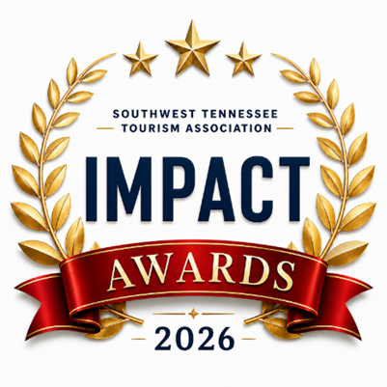

Southwest Tennessee Tourism Impact Awards
Categories

I. Premier Leader Impact Awards
These represent the top tier of recognition
• Impact Leader of the Year Award
The highest honor recognizing an attraction, event, organization, or initiative that made a transformational impact on tourism and regional visibility.
• Impact Organization of the Year Award
Honors a DMO, chamber, nonprofit, or tourism-related organization driving measurable growth and collaboration.
• Impact Legacy in Tourism Award
Lifetime achievement recognizing long-term contributions to tourism development.

II. Experience Laureate Impact Awards
Recognizing places and experiences visitors directly engage with.
• Attraction of the Year
• Event / Festival of the Year
• Venue of the Year – Honors a lodging, restaurant or retail establishment that has made an impact on tourism
• River, Outdoor & Nature Experience of the Year

III. Individual Impact Makers Awards
Recognizing people behind the visitor experience.
• Tourism Professional of the Year
• Lodging
• Dining
• Retail
• Attraction
• Frontline Maker Award
Honors guides, rangers, and guest-facing staff who go above and beyond.
• Emerging Tourism Maker Award
Recognizes rising professionals with at least 3 years of experience.

lV. Special Recognition Awards
Lasting Impact Award

